Assignment -5

1) Write a query that will give you all orders for more than Rs. 1,000.

Solution- select \* from ORDERS where Amt > 1000;

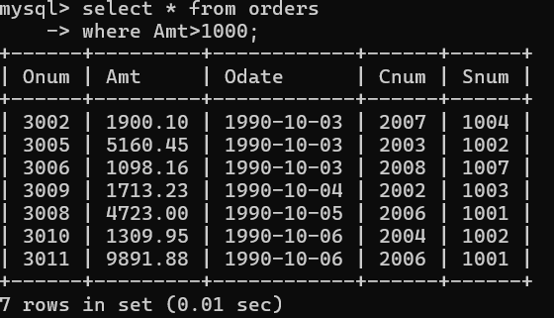

2) Write a query that will give you the names and cities of all salespeople in

London with a commission above .10.

Solution- select Sname,City from SALESPEOPLE where City= 'London' AND Comm > 0.10;

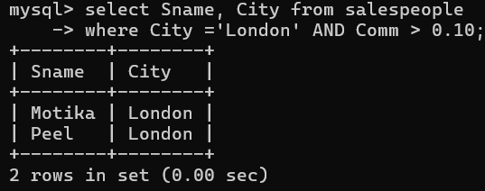

3) Write a query on the Customers table whose output will exclude all customers

with a rating <= 100, unless they are located in Rome.

Solution- select \* from CUSTOMERS where Rating > 100 OR City= 'Rome';

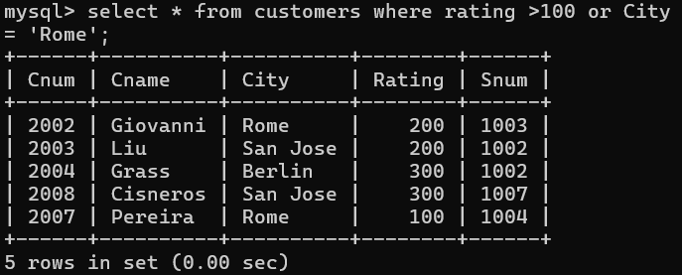

4) What will be the output from the following query?

Select \* from Orders

where (amt < 1000 OR

NOT (odate = ‘1990-10-03’

AND cnum > 2003));

Solution- +------+---------+-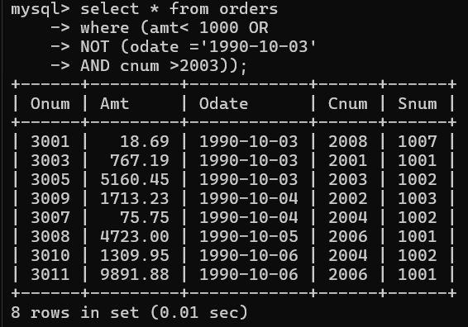

5) What will be the output of the following query?

Select \* from Orders

where NOT ((odate = ‘1990-10-03’ OR snum

>1006) AND amt >= 1500);

Solution- +------+---------+------------+----

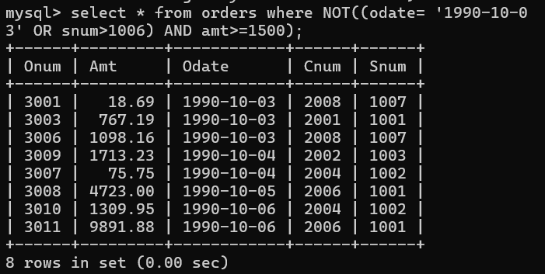

6) What is a simpler way to write this query?

Select snum, sname, city, comm From Salespeople

where (comm > .12 OR comm <.14);

Solution- select Snum, City ,Comm from Salespeople where Comm between 0.12 AND 0.14;

